Arrange each picture with its title and description from smallest to biggest.

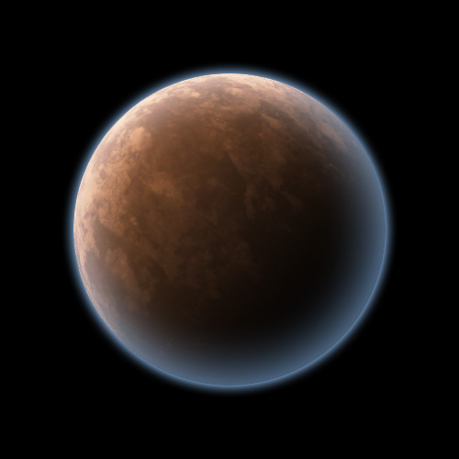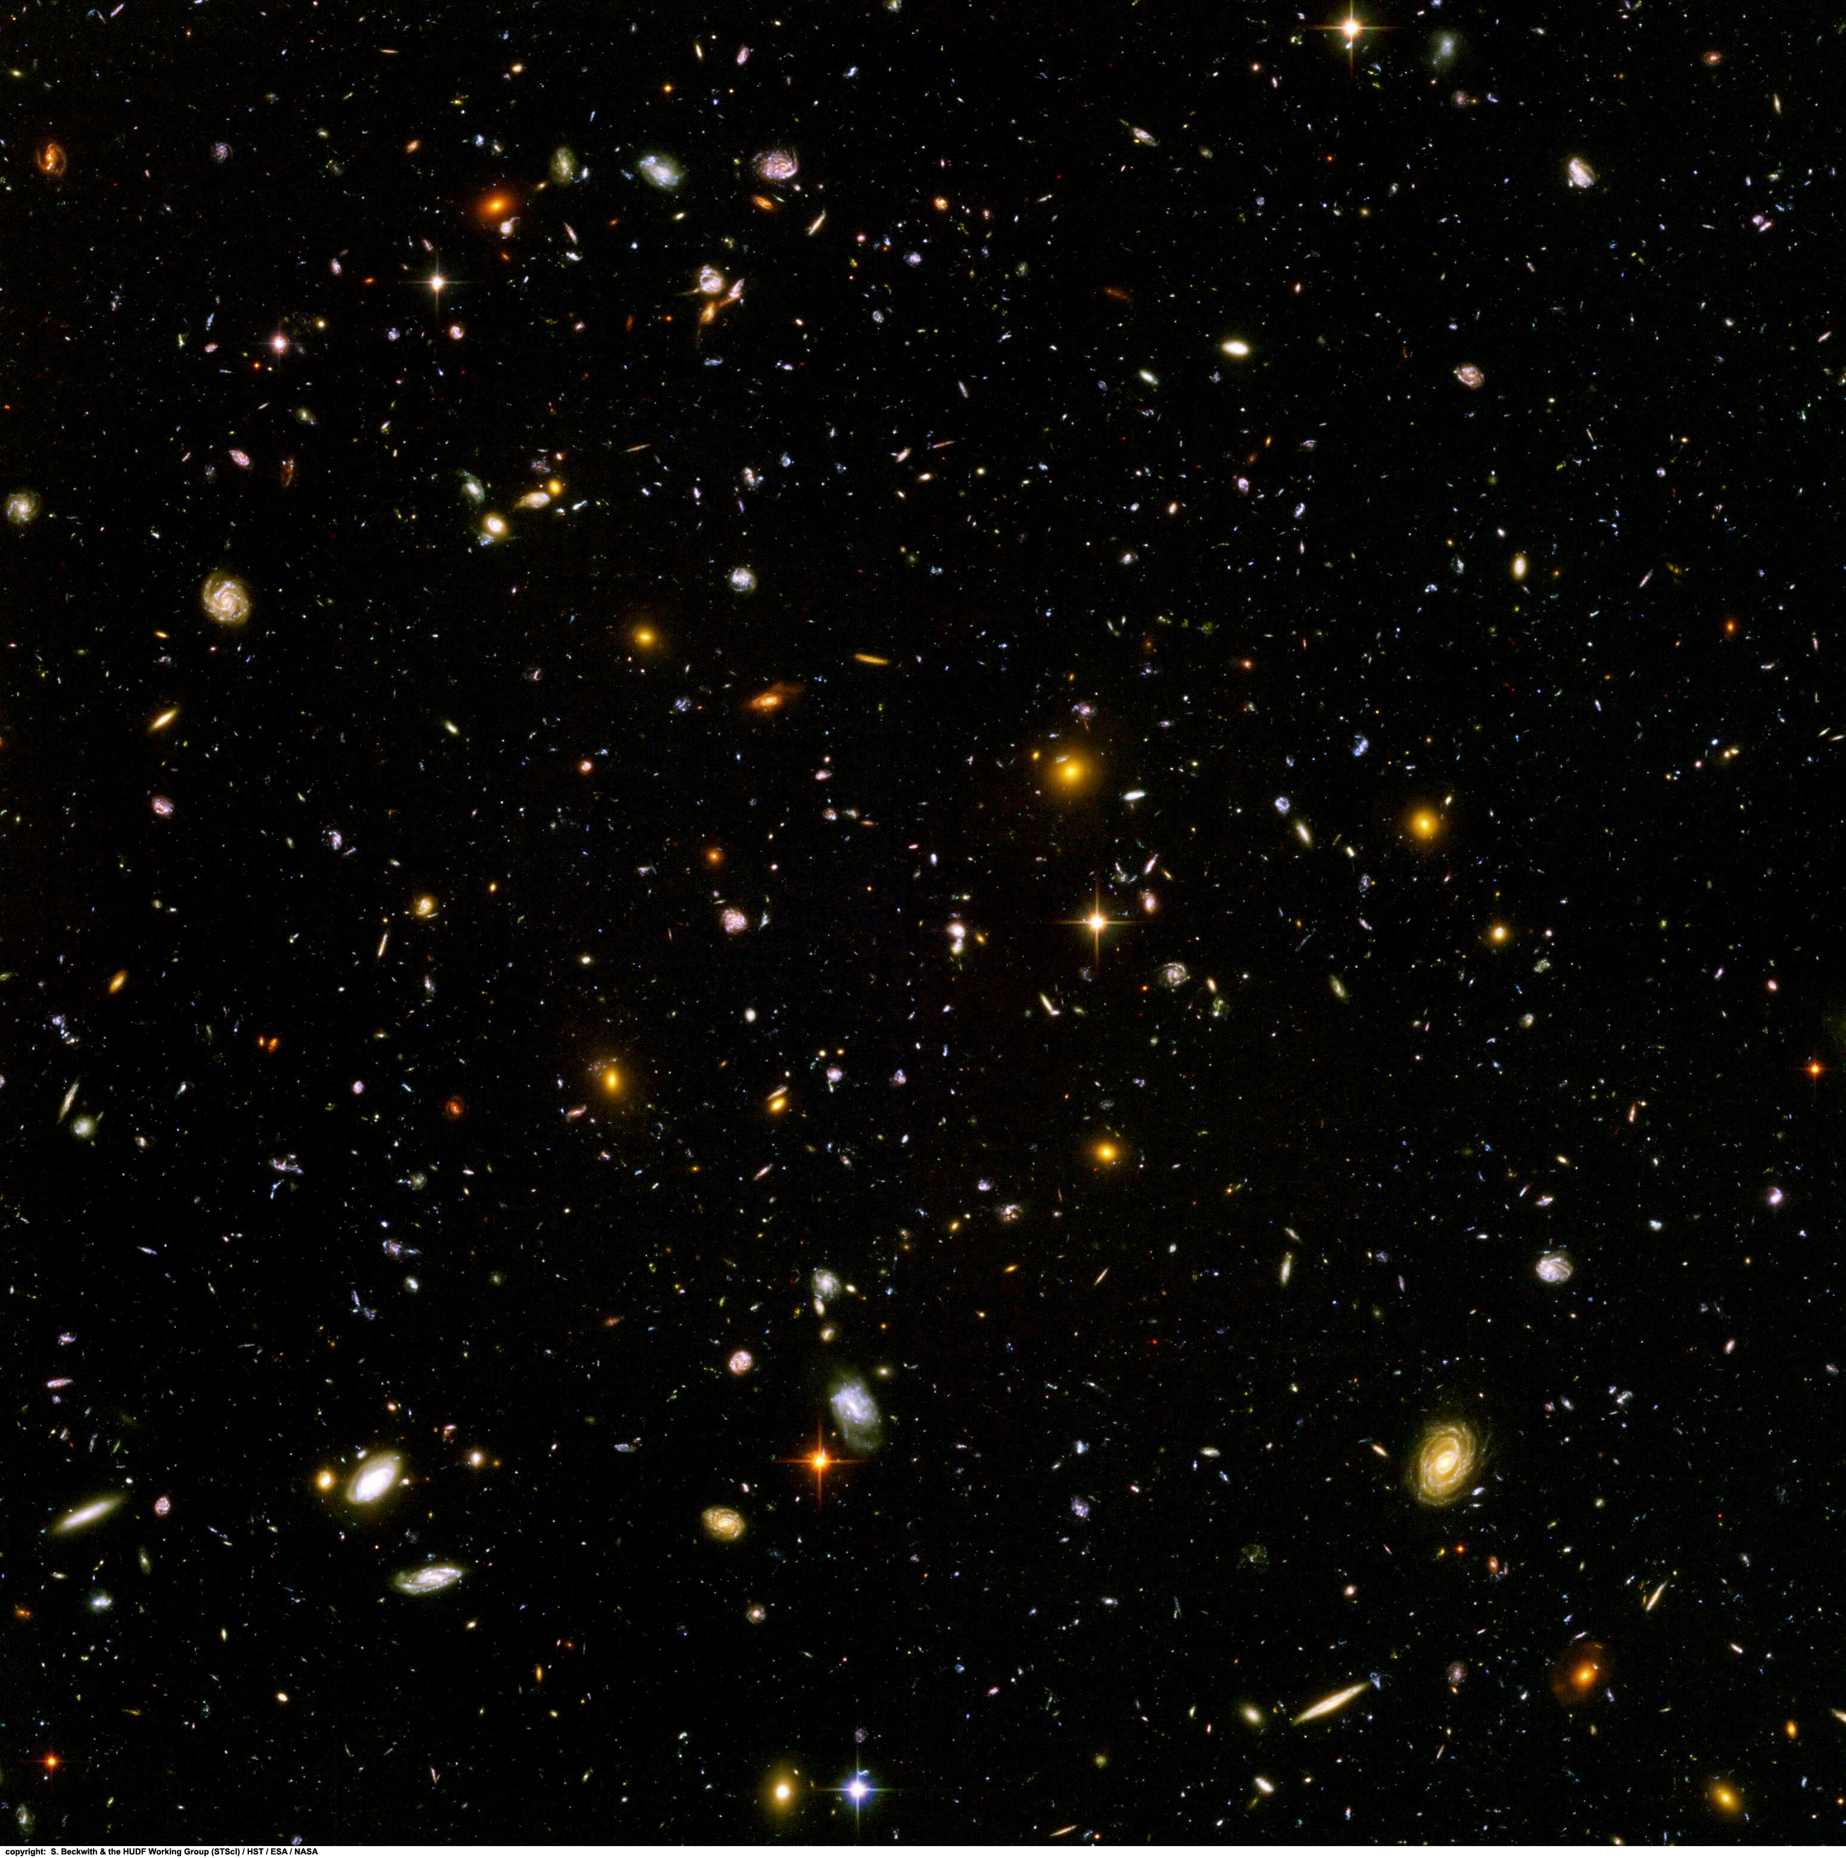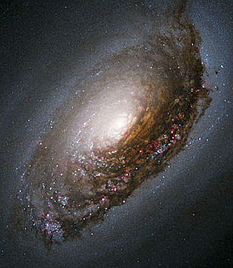

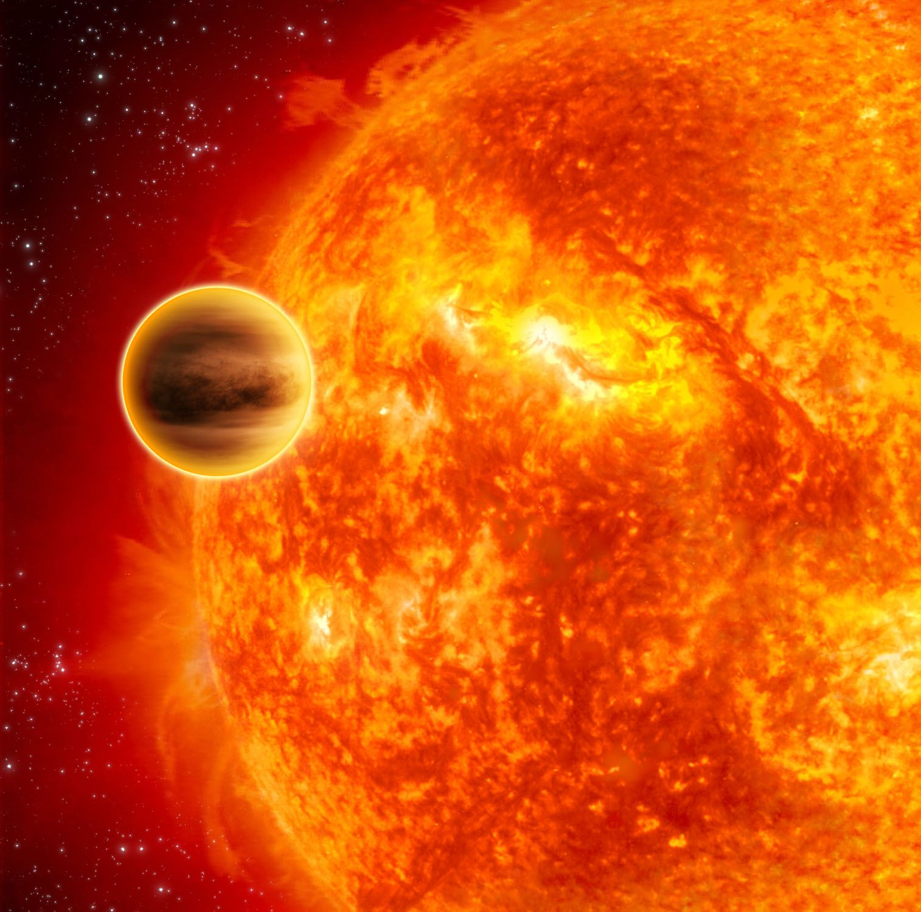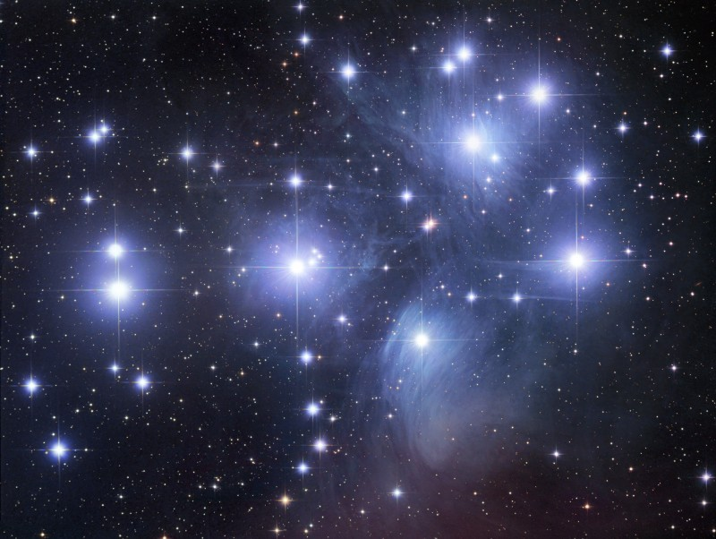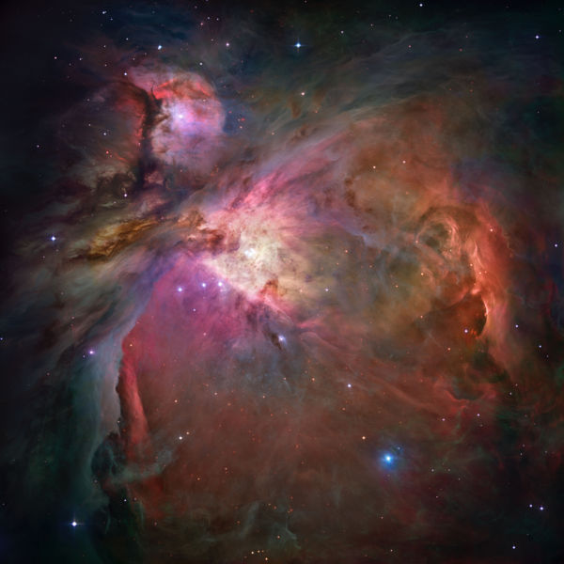

Constellations are groups of stars that only appear to be close together. Star clusters have stars that really are close together. They can be irregular like this one or spherical.

Galaxies are to the Universe what stars are to galaxies. Galaxies are often bigger than 100,000 light years across. They contain star clusters and nebulae.

A star is a sphere of hydrogen squashed by its own gravity. It is millions of degrees inside a star, hot enough for hydrogen to fuse and form heavier atoms. This process gives out energy we enjoy.

A cool body of material that may contain rock or metals but maybe just gas.

Nebulae are vast clouds of gas (usually hydrogen but can contain heavier atoms too). The denser regions of nebulae may coalesce to form stars.

Every spot in this picture is a galaxy. This picture is a tiny fragment of the sky. Any other fragment would contain as many galaxies. The universe contains billions of galaxies including ours.

Star Planet Star cluster Galaxy Nebula Universe

