Lesson 5:
Use Text Quest chap6.4
In the darkest room you can get set up a 12 volt lamp with a variable voltage power supply. Increase the voltage from 2-12 volt and watch the filament go from reddish to whitish. Watch the lamp through a spectroscope and watch the spectra expose more of the spectrum as you increase the voltage. NB there are no green stars. If a star is hot enough to emit in the green it is also emitting in the red. Red plus green gives yellow. (additive colour mixing) and there are yellow stars.
Examine this David Malin star trail pic.
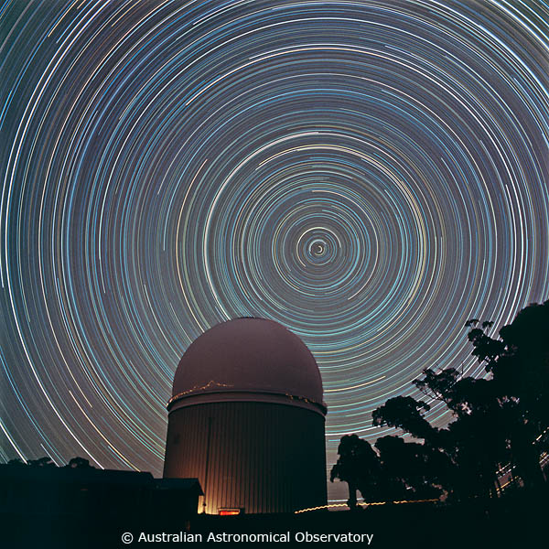

Note: 1: the colour of stars
2: The person walking with the torch
3: The person who came out of the dome for a smoke!
4: How long was the shutter open for?
5: which way was the camera pointing?
6: If you were at the south pole where would you point the camera to get this pic?

Set up the spectral lamps and obtain the spectroscopes again.
Not only does the colour of the star tell us how hot the star is and therefore how luminous it is. When atoms are made hot they can emit light that is characteristic of the element. Such a spectrum is called an emission spectrum. If light passes through a gas those unique colours are removed from the spectrum and the spectrum with black bars where those colours ought to be is called an absorption spectrum. Knowing this we can use a telescope in combination with a spectroscope and say exactly what elements are in the stars.
Examine the spectral lamps, get students to draw the colours perhaps. Point the spectroscope at the flouro lights and ask what element is in them (mercury)

When a source of sound approaches or recedes the pitch of the source varies because the medium restricts the speed of sound to its own speed limit. An approaching sound has a higher than expected pitch (frequency) and a receding source has a lower than expected pitch. A similar thing happens with the light from stars and galaxies. If the object is approaching the wavelength shortens and the light shifts to the blue. So if that flouro light was hurtling towards us the bars of light you saw would all be there but shifted a little to the blue. If a star is spinning on its axis, we can tell how fast it is spinning by looking at the light that comes from each edge of the star. The receding edge will be red-shifted and the approaching edge will be blue-shifted. The amount of shift tells us how fast the motion is.

(Radar speed guns used by the police use this effect to measure the speed of cars.)

In 1929, Edwin Hubble announced to the world that the most distant galaxies were moving fastest and that they were all moving away. This suggested that the universe was once moving faster than it is now. (the further you look away the further back in time you are seeing.) Just as when you throw a ball in the air, it is moving fastest when it just leaves your hand. This data suggested that the Universe began in one spot. The data also suggested a way to calculate when the Universe began. (whatever that means)

