Inverse Square Law & Cepheid variables.

1/ An astronomer recognises that two stars are identical from their spectrum but she measures one of the stars to be 100 times more dim than the other. She reasons that the bright star must be closer and she knows how far away it is. The name of this close star is Alpha Argo and it is 200 ly away.
- How far away is the dim star?
- What method could she have used to measure the distance to Alpha Argo?
- Could she have used this method to measure the distance to the dim star?
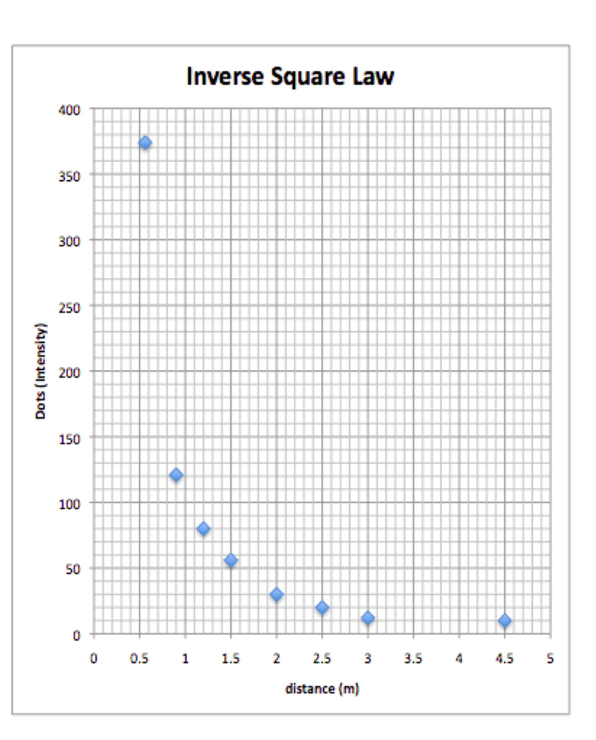
2/

A student models the way the light from a star dwindles using a slide of dots projected on a target. How many dots does she count at 0.9 from the projector?
How many dots does she count when she is 1.8 from the projector and explain your answer?

3/ Here is a graph of the maximum brightness of Cepheid variable stars vs their period. 40

Brightness 30

20

10
1 2 3 4 5 6 Period/ days
An astronomer knows about Cephi 21 which is a Cepheid variable of known brightness 32 and 200 ly away. The astronomer observes a star in a distant galaxy which has a period of 4 days but it only appears to have a brightness of 0.0032. How far away is the distant star?

4/ When stars of certain type explode as a super nova they can be as bright as the entire galaxy of which they are part. Objects of known brightness are called
“standard candles”. Type 1A super novae are standard candles because when they explode they all have the same brightness. In 1987 a super nova happened 170,000 ly away. (arrowed in LH pic. Supernova in RH pic)

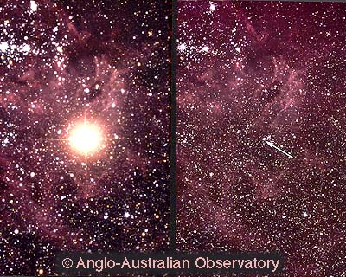

Early this year another type 1A super nova was observed but it only appeared to be 1,000,000 as bright. How far away is this distant super nova? Is it part of our galaxy?

