Cosmology- A year 10 text.
Cosmology is the study of the origin and fate of the Universe. Astronomy is the study of the things that can be found in the Universe.
Ancient cultures had their story about the Universe. They could contemplate the Sun, look out at night and wonder about the Moon, the stars, the independent movement of the planets and their own existence. Mystery, awe and wonder at their own existence would never be far from their thoughts. When they imagined their origin stories they included humans, their predicaments and responsibilities in the story. Eg Egyptians had to behave in a certain way or the Universe would collapse.
Psalm 8:3 When I look at your heavens, the creation of your fingers, the moon and the stars that you have set in place-- 4 what is a mortal that you remember him or the Son of Man that you take care of him?
This was written before 500 BC and you can be sure that it was not a new thought. Modern science can tell you what all the bits are doing and have done, but sheds no light on why we are here. Science offers nothing about our responsibilities and provides no solace.
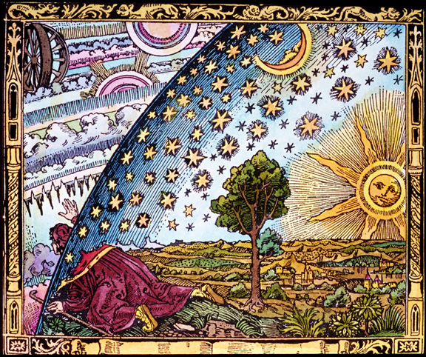

Theological reflections aside, the model of the Universe that gained currency in the ancient western world goes by a number of names. Eg The Aristotelian, the Classical, the geocentric, the Ptolmaic and the Medieval. It was a perfectly sensible model in that it satisfied the senses.
The Earth was regarded as stationary and nailed in at the centre of the Universe. All heavenly bodies were thought to rotate around the Earth fixed in crystal spheres. The outermost sphere held the stars. They were regarded to be all at the same distance. Heaven was outside the sphere of stars.
In the first Century AD Ptolemy produced a system by which the positions of the planets could be predicted within this geocentric model.
This Aristotelian model was the intellectual air that everyone breathed in the western world and it went unchallenged until the late renaissance. Copernicus (1543) proposed a heliocentric model that was adopted with little fuss by many Protestants (but not all) and rejected by many Catholics (but not all) (Yet another bone of contention for the Reformation). Kepler gave a mathematical form to this heliocentric Solar System and Galileo began the telescopic study of the heavens. (1609) Throughout the 18th Century the telescopic study of the heavens really got going. Things other than stars were seen for the first time. Fuzzy things they called Nebulae were catalogued. Some of these were amorphous in shape but others had a distinct spiral shape. They had no idea about the distance of these objects. They did not know if they were looking at a mouse at the end of their arm or and elephant in the next paddock!
The method of parallax had been used since the first century to measure the distance to the Moon. As the centuries went by they were able to measure the distance to the planets and to the Sun using the same method but all bets were off as far as the stars and the nebula were concerned. The fact that there was no observable parallax for the stars was evidence for them all being the same distance away. Newton used a version of the inverse square law to approximate the distance to a star but he lost his nerve with the distance that he came up. It was so huge he could not believe it.
Unless you face up to the business of how to measure distance to things you cannot reach, then we have little to say about the structure of the Universe.
What has happened in the story so far is the Universe has acquired measurable depth the Aristotelian model did not really have. Understanding how parallax works is a good thing for you to appreciate. You should see the limitations of the method, especially the assumption of parallel lines and the fact that no measurement is perfect but that a close measurement is better than no measurement.
In 1837 parallax of a star was detected for the first time. The apparent movement of the star against the distant background was so slight that it needed the best telescope technology the 19th Century could provide before it was detectable. Today parallax will detect a star out to a distance of 2-300 ly. Even on our base line of 300 million km (the diameter of the Earth’s orbit), we cannot detect the parallax of stars beyond that distance.
By the end of the 19th Century we had a good catalogue of what was in the sky. We had begun to take an interest in the spectra from the stars, Astronomical photography had become useful, we knew the distances to some stars but there was still no idea about the size of the Universe or the distances to the Nebula and there was no clue that the Universe was in motion ie expanding. Monthly and yearly motion of the stars and planets was observed but this was due to the motion of the Earth and planets around the Sun. The stars appeared to move as the Earth moved around the Sun but their positions relative to each other did not change.
The spectra of a star was also a clue as to how bright it really was. Astronomers were able to measure the brightness of stars with a light meter and use the inverse square law. This means that if two identical stars are observed and one is 1/9th as bright it is 3 times further away than the bright one.
In the early 20th Century at Harvard in the USA large numbers of women were employed to work in the basement of the University gazing at photographic negatives of the night sky. Many of these women were deaf. Their job was to catalogue the stars. Some of these women went on to become very famous. Because they were working with the primary data they began to use their initiative and form their own opinions about what the data was telling them.

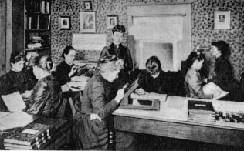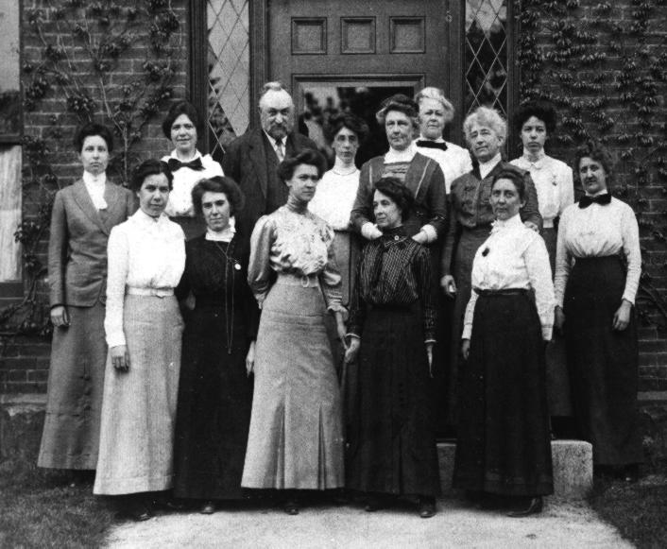

Annie Jump Cannon worked out a way of cataloguing the stars according to their colour (O,B,A,F,G,K,M) and therefore temperature.
Henrietta Leavit noticed that some stars fluctuated in their brightness in a regular way. She noticed that the maximum brightness of the brightest of these stars had the longest period of fluctuation and that there was a linear relationship between the maximum brightness and the period of fluctuation. She was able to use parallax and Intensity vs distance graphs to measure the distance of these

variable stars (cepheids) found in the spiral nebula. She found that the spiral nebulae were much further away than could have been imagined and that they were different to the other amorphous nebulae. The work of Henrietta enabled astronomers to get their first fix on the real structure of the universe. The Universe consists of billions of galaxies separated by millions of light years. Each galaxy is about 100,000 light years across and contains billions of stars (billion = 1000 million).

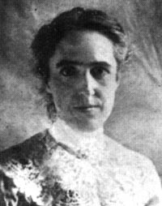 Henrietta Leavit
At that stage, in the first two decades of the century there was still no inkling that the universe was moving. The work of William Thomson and others in England had begun to think about Cosmology in terms of energy. When you light a candle, it will eventually burn out. They could not avoid the question of stars. When had they been lit? How long would they last? The universe of stars had to have a beginning. In energy terms it had to run down and when would that be? Before the understanding of Nuclear energy (Einstein 1905) Thompson’s limit for our sun was about 20 million years. This had implications for geological and evolutionary theories.
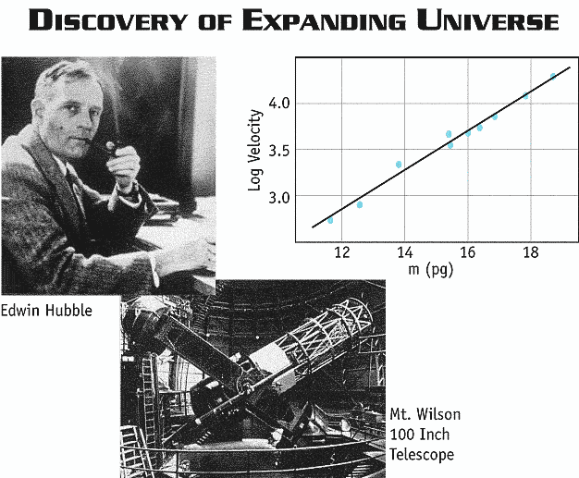

During the 19th Century the observation that different elements gave out light of distinctive colours enabled astronomers to say what elements could be found in the stars. The light from the star was sent through a prism that spread the colours out into the distinctive bands of colour that were the fingerprints of the elements. In the 1920s Edwin Hubble noticed that these coloured bands were shifted to longer wavelengths. He concluded that the source of the light ie the galaxies were moving away from our Earth (Doppler effect). In 1929 he announced to the world that the further away the galaxies were, the faster they were going. He concluded this because of their greater redshift.

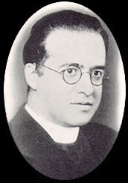
Hubble himself did not make any conclusions from the observation of the retreating galaxies. Note that this was only true of the more distant galaxies. Some closer galaxies are actually moving towards us. A Belgian priest called George Le maitre proposed the idea of the “Primeval Atom.” This was the idea that once the entire Universe was concentrated at one point. This model was certainly supported by the evidence.

George LeMaitre

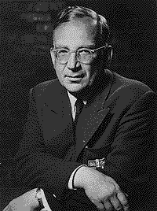 George Gamow
A little later George Gamow prepared a mathematical model of what might have happened if indeed the Universe had begun this way (1948). He predicted that the Universe should be 75% Hydrogen and 25% Helium. Since the Universe was expanding so rapidly Helium was the only other element that could have formed before the Universe would have dispersed too much to form anything else. The heavier elements would have to wait for some later coalescing of material in stars before they could form.

Gamow also predicted that there should be some remnant of radiation typical of a body at about 5º K. When this radiation was released about 300,000 years after the Big Bang began this radiation would have been typical of something much hotter but the very fabric of the Universe that supported this radiation has stretched and the wavelength of the radiation has stretched along with it.
Since the (1948) paper was written the percentages of H and He have been confirmed and in 1965 the radiation was detected. (Cosmic Microwave Background). This sequence of Hypothesis based on data, prediction from the hypothesis and the confirmation of prediction is classic scientific method.
If you consider the graph on the picture of Hubble, the gradient of the graph is the reciprocal of the age of the Universe ie the time at which all the material was at a single point. Each measurement of the distance and speed of recession of the galaxies would be uncertain thus lending great uncertainty to the age of the Universe. This is the case because of the greater range of possible choices for the line of best fit and therefore gradient. 15 year ago 15 5 billion years was as close as anyone dared to suggest. Better technologies and better understanding of objects they are measuring has improved the value of the age to 13.70.2 billion years. Notice how the extra significant figure has enabled a more precise value ie 0.2 rather than 5.
The Cosmology story is unfinished. Many problems remain. In recent years the Universe has been measured to be accelerating. This suggests that there is a force other than gravity that pushes rather than pulls. What force enabled the so-called Big Bang. Where and in what form is the unseen mass of the Universe. Despite these and many other questions the basic data of the size and expanding nature of the Universe cannot be ignored. These facts alone give the Universe a history that can be studied.
There are many opportunities for students to ask and explore their own questions and to present their findings on a poster. The topics can be quite basic things like telescopes and other tools of the trade or they could be intermediate factual things like the Electromagnetic spectrum and atomic spectra through to esoteric problems like black holes, the missing mass, curved space, relativity and the accelerating universe.

